Teradata University Challenge

# Author(s)

* **Ahmed Asraf**
  + *Virginia Commonwealth University*
  + [*asrafa@vcu.edu*](mailto:asrafa@vcu.edu)
  + *Information Systems*
  + *Undergraduate*
* **Gabriel Rodriguez**
  + *Virginia Commonwealth University*
  + [*rodriguezgm@vcu.edu*](mailto:rodriguezgm@vcu.edu)
  + *Information Systems*
  + *Undergraduate*
* **Fady Freeny**
  + *Virginia Commonwealth University*
  + [*freenyf@vcu.edu*](mailto:freenyf@vcu.edu)
  + *Information Systems*
  + *Undergraduate*
* **Brian Smedley**
  + *Virginia Commonwealth University*
  + [*smedleys@vcu.edu*](mailto:smedleys@vcu.edu)
  + *Information Systems*
  + *Undergraduate*

# Faculty Advisor

**Joe Cipolla** - Department of Information Systems - [jcipolla@vcu.edu](mailto:jcipolla@vcu.edu)

# Summary

We analyzed a non-profit organization’s data and found that there were a decline in retaining monthly donors as well as average donation per year between 2012 and 2017.

The questions chose to answer are regarding the lifespan of a monthly donor, the rate of monthly donor retention, and whether monthly donors retained for more than a year increase their donations or otherwise.

Based on our analysis, we deduced that the company failed to adapt to changes, whether in the market, or in the company culture. The following report will show these findings in more detail.

# Problem and Motivation

There is a steady decline in monthly donors’ consistency regarding staying with the organization as well as a decline in average monthly donations each year. The average monthly donations in 2012 has declined by approximately 43.3% by the year 2017.

# Approach

For this project we decided to answer a development question regarding the lifespan of a monthly donor, the rate of monthly donor retention, and whether monthly donors retained for more than a year increase their donations or otherwise.

Answering these questions and identifying measuring discrepancies in the findings will help identify the focus of the solution.

# Datasets

The datasets used were the records of the organization. The specific records used were opportunity and account information. These records were chosen to measure donation amounts per year, and metadata about these donations that would help us answer our questions.

# Tools and Analytics

The analysis that follows was done using **Tableau Prep** and **Tableau Desktop**.

These tools helped us clean the data, aggregate and create calculated fields as well as illustrate our results using graphs.

# Results

After debating what the donor’s lifespan meant for us, we decided to define it as the length of their commitment to our organization, as opposed to their actual life span. This was calculated by finding the difference between their first donation and their last. The unit for the result is **days**.

Then we compared the average lifespan of **monthly** donors to **annual** and **quarterly** donors to define a baseline and develop a hypothesis on the consistency of donors.

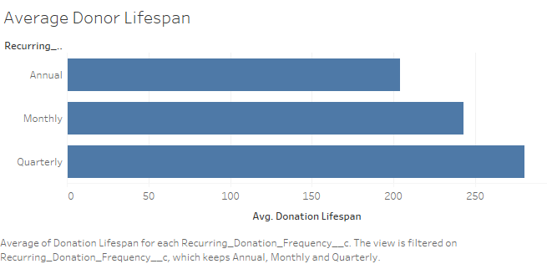

Our result shows that monthly donor lifespan is approximately 243 days. This is about 16% more than annual donors, who average at 204 days, yet 13.3% lower than quarterly donors who average at 280 days.

After that, we analyzed the monthly donors’ average donation over the years. This helped us establish a baseline of their overall activity and define the annual fluctuation of donations.

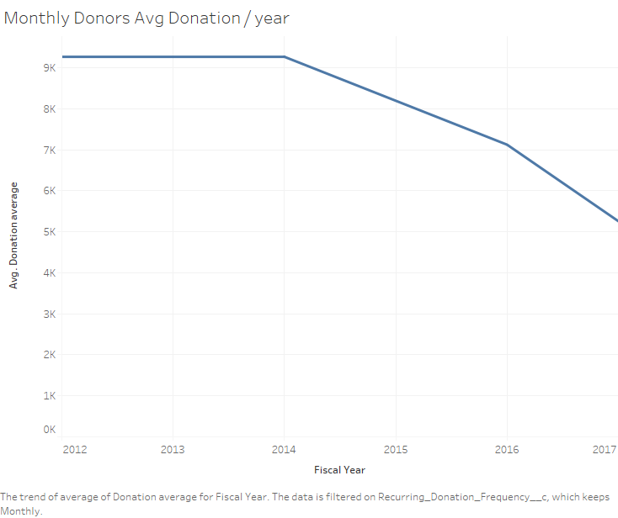

As the graph shows, there is a consistent decline in the donation amount average for monthly donors following the year 2014. This average peaked around $9,265 per donation between 2012 and 2014.

In the following two years there has been a steady decline in average donations to $7,123 in 2016, and an even lower average in 2017 reaching $5,257. In other words, average monthly donations in 2017 was 43.3% less than the peak in 2012.

This decline could indicate a failure to reach the target audience effectively through marketing efforts. It could also mean that there was a shift in market trends, to which the organization could not adapt.

Finally, we analyzed how many monthly donors are retained each year. This showed how the rise and decline in the number of monthly donors.

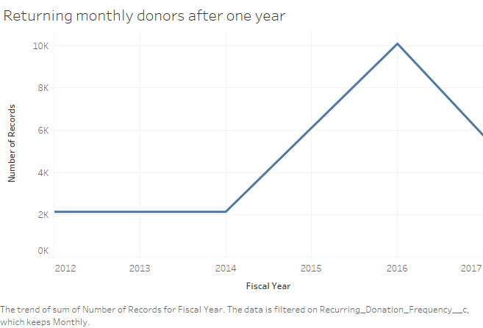

This graph shows a steady rate of returning monthly donors between years 2012 and 2014. However, there was a steep rise in returning monthly donors, by around 74.7% between years 2014 and 2016. In 2017 this number declined by around 43%.

This shows a discrepancy between the average donation amount each year and the returning monthly donors for the same years.

Our conclusion is that there might have been a shift in market trend or a change in the organization's marketing strategy which attracted more donors to remain the following year, but skeptical enough not to increase their donation.

We suggest that the organization looks over their marketing efforts, culture, and market trends and adapt to the new market accordingly.

# References

This project was a collaboration between our team and Team 5 (Section 002): Abdulaziz AlFallaj, Yousef AlObaid, Majed AlMarri.